**ACCESS CONTROL LIST (ACL)**

**WHAT IS ACP?**

* An access ACL is the access control list on a specific file or directory for specific users or group members.

**TO VERIFY THE DEFAULT ACL ON A FILE/FOLDER**

* getfacl file/foldername

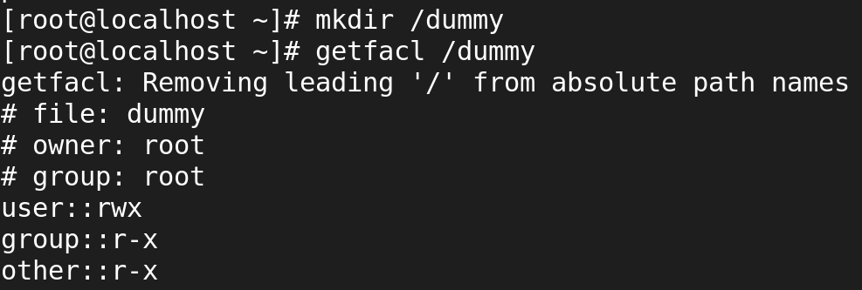

**TO SET ACL ON A FILE FOR A SPECIFIC USER**

* setfacl -m u:username:rwx filename
* setfacl -m 'u:username:7' filename

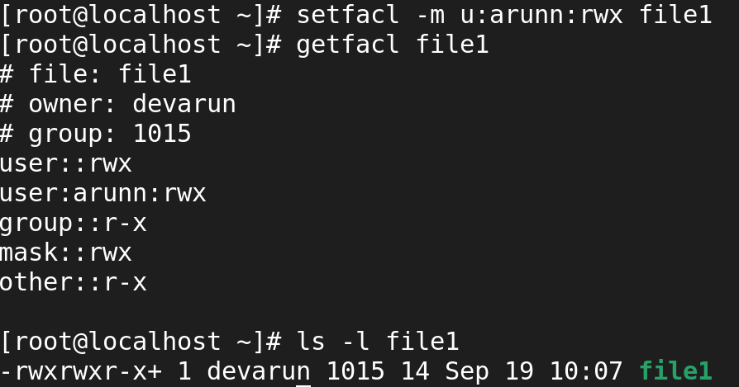

**TO SET ACL ON A FILE FOR A SPECIFIC GROUP**

* setfacl -m g:groupname:rwx filename
* setfacl -m g:groupname:7 filename

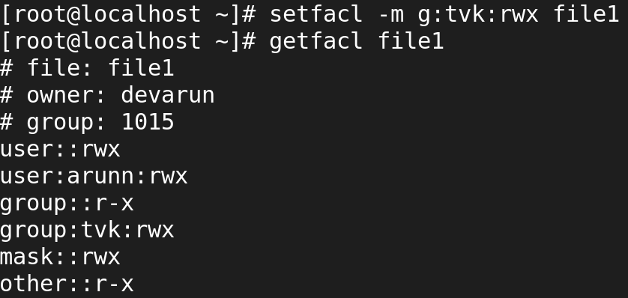

**TO REMOVE ACL ON A FILE FOR A SPECIFIC USER**

* setfacl -x u:username /secure

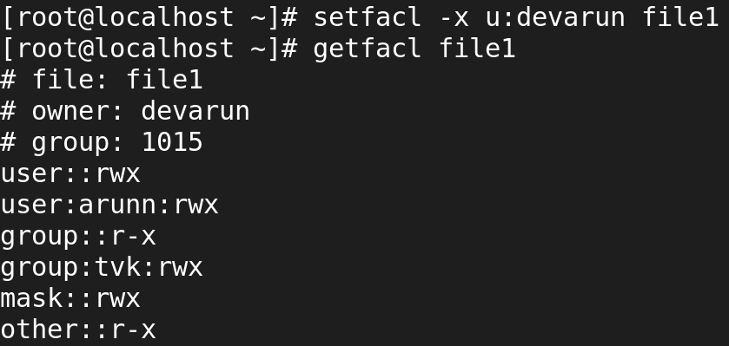

**TO REMOVE ACL ON A FILE FOR A SPECIFIC GROUP**

* setfacl -x g:groupname /secure

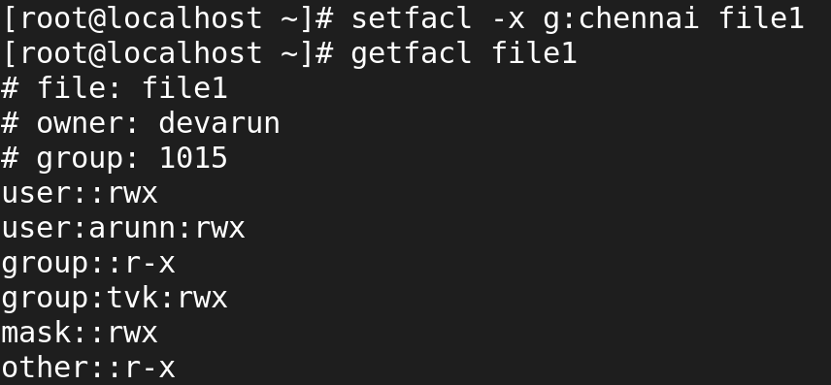

**TO REMOVE ALL ACL**

* setfacl -b file/directory

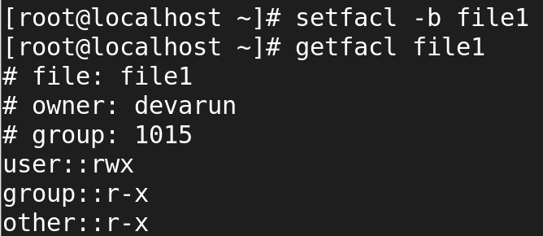

**TO SET DEFAULT ACL FOR A DIRECTOY/FILE AND ITS CONTENTS**

* setfacl -d -m u::7,g::0,o::0 filename

